HUMAN VS MACHINE

AI vs Human Text Detection
Technical Documentation & Model Evaluation Report
Random Forest classification • dataset integrity • overfitting diagnosis • model revision

Document purpose
This report documents the Human vs Machine project from its original 100% Random Forest result through the leakage/overfitting investigation, feature-integrity audit, revised raw-text pipeline, observed performance, deployment architecture, limitations, and recommended next experiments.

Project evidence base
- Random_Forest_AI_Detector_Refined_No_Feature_Selection.ipynb
- docx.docx (project recommendations and change rationale)
- ai_detection_dataset.csv
- Random_Forest_AI_Detector_Regularized_7_Text_Features.ipynb
- Random_Forest_AI_Detector_Feature_Integrity_Revision.ipynb
Report date: 6 October 2026

Contents
1. Executive Summary
2. Project Objective and Scope
3. Dataset Description
4. Original Modelling Approach
5. Why the 100% Result Was a Red Flag
6. First Revision: Seven Defensible Text Features
7. Feature-Integrity Audit
8. Final Revised Modelling Pipeline
9. Performance Results
10. Interpretation of Results
11. Gradio Deployment Architecture
12. Recommendations to Improve Accuracy
13. Recommended Experiment Roadmap
14. Limitations and Risks
15. Reporting Guidance
16. Conclusion
Appendix A. Feature Definitions
Appendix B. Key Hyperparameters and Validation Logic
Appendix C. Reproducibility Checklist

1. Executive Summary
The Human vs Machine project aims to classify text as Human (0) or AI-generated (1) using a Random Forest classifier. The initial notebook achieved 100% cross-validation and held-out test performance when every numerical dataset column was supplied to the forest. Reproduction of that original configuration confirmed a perfect 137/137 Human and 137/137 AI classification on the 20% test split. Rather than treating this as a successful detector, the project correctly investigated leakage, dataset artefacts, and overfitting.
Central finding
The project’s main technical finding is that the very high accuracy is driven by information embedded in the supplied numerical feature columns. When seven linguistic features are independently reconstructed from the raw text, held-out performance falls to approximately 51% and a large train-test gap remains. This means the current raw-text signal is weak under the seven-feature representation, while the supplied feature values require provenance verification before they can be trusted as deployable inputs.

- Dataset: 1,367 rows × 17 columns; 684 Human and 683 AI samples; no exact duplicate rows or exact duplicate texts.
- Original model: all 14 numeric predictors, Random Forest, 5-fold GridSearchCV, 80/20 stratified split; 100% train/test/CV F1.
- Integrity problem: the seven supplied linguistic columns show correlations of only about -0.03 to 0.06 with the same quantities recomputed from text; character_count and sentence_count are non-integer in all 1,367 rows.
- Defensible final pipeline: raw text → deterministic seven-feature extraction → stratified split → regularized Random Forest → 5-fold CV → independent test → feature importance → same model in Gradio.
- Observed final-model behavior: ~85.64% training accuracy vs ~51.09% test accuracy, indicating substantial overfitting and near-chance generalization.
- Next priority: improve dataset provenance and raw-text representation before further hyperparameter tuning or claiming production-grade AI detection.

2. Project Objective and Scope
The project is a binary text-classification system intended to distinguish Human-authored text from Machine/AI-generated text. The modelling constraint retained throughout the revision is that Random Forest remains the classifier. The project also includes exploratory data analysis (EDA), model evaluation, feature interpretation, model persistence, and a Gradio interface for end-user prediction.

2.1 Target definition
Label | Meaning
0 | Human
1 | AI / Machine-generated

2.2 Core design principle adopted after the audit
A modelling feature must be legitimate, reproducible for future unseen text, and independent of hidden dataset-generation artefacts. A high score is not accepted as evidence of a good detector if the input variables cannot be reconstructed from the same raw text that a user will provide at inference time.
Important terminology
Random Forest choosing candidate features at tree splits is not the same thing as automatic input-feature selection. The original notebook still exposed the model to every numeric column. Feature importance also explains a fitted forest; it does not retroactively prove that every input was valid.

3. Dataset Description
The supplied CSV contains 1,367 observations and 17 columns. The target is almost perfectly balanced, so simple accuracy is not being inflated by a dominant class.
Dataset property | Observed value
Rows | 1,367
Columns | 17
Human samples (0) | 684
AI samples (1) | 683
Exact duplicate rows | 0
Exact duplicate text_content values | 0
Numeric predictors excluding label | 14

3.1 Available variables
Role | Variables
Raw content | text_content
Categorical descriptor | content_type
Length / structure | word_count, character_count, sentence_count, avg_sentence_length, avg_word_length
Lexical / readability | lexical_diversity, flesch_reading_ease, gunning_fog_index
Style / mechanics | punctuation_ratio, grammar_errors, passive_voice_ratio
Synthetic / behavioural style indicators | predictability_score, burstiness, sentiment_score
Target | label

The presence of a numerical feature in the CSV does not by itself establish that it is safe for modelling. The later integrity audit evaluates whether the supplied linguistic values correspond to the actual text.

4. Original Modelling Approach
The original notebook intentionally avoided a manually written feature list. It selected every numeric column except label and supplied those columns directly to Random Forest. The object/text columns, including text_content, were excluded from the main classifier.
Original modelling flow
CSV → every numerical column except label → stratified 80/20 split → Random Forest → GridSearchCV (5-fold, F1 scoring) → held-out test → feature importance → saved model.

4.1 Original search space
Hyperparameter | Values
n_estimators | 100, 200
max_depth | None, 10, 20
min_samples_split | 2, 5
min_samples_leaf | 1, 2
CV | 5 folds
Selection metric | F1 score

4.2 Reproduced original performance
Metric | Result
Best 5-fold CV F1 | 100.00%
Training accuracy | 100.00%
Test accuracy | 100.00%
Training F1 | 100.00%
Test F1 | 100.00%
Test precision | 100.00%
Test recall | 100.00%

The held-out confusion matrix was perfectly diagonal: 137 Human texts and 137 AI texts were all classified correctly.
Actual / Predicted | Human | AI
Human | 137 | 0
AI | 0 | 137

4.3 What the original forest relied on
Feature importance from the reproduced original model was heavily concentrated in a small group of supplied numeric variables:
Rank | Feature | Importance
1 | predictability_score | 0.394
2 | burstiness | 0.266
3 | lexical_diversity | 0.167
4 | grammar_errors | 0.107
5 | avg_sentence_length | 0.031
6 | sentence_count | 0.018

Class means also show unusually strong separation in several of these supplied variables:
Feature | Human mean | AI mean
predictability_score | 44.626 | 84.982
burstiness | 0.602 | 0.204
lexical_diversity | 0.705 | 0.850
grammar_errors | 2.911 | 0.515
avg_sentence_length | 11.961 | 15.002

These differences do not automatically prove leakage. They do, however, explain why a tree ensemble can separate the classes with little difficulty and justify investigating how those variables were generated.

5. Why the 100% Result Was a Red Flag
Perfect performance is possible in principle, but for a noisy real-world task such as AI-vs-human text detection it requires unusually strong evidence. Three issues made the result especially suspicious in this project:
- The model received every numerical column without first establishing whether each variable represented information legitimately available from a new raw text.
- The strongest original predictors included variables such as predictability_score and burstiness whose provenance was not documented in the project materials.
- The dashboard originally extracted a different set of features from pasted raw text, meaning the reported model and deployed interface were not using an identical feature pipeline.

5.1 Overfitting vs leakage vs dataset artefact
Concept | Meaning in this project
Overfitting | The forest learns patterns in the training data that do not generalize to unseen samples. A large train-test or train-CV gap is a warning sign.
Data leakage | Information unavailable at real inference time, directly or indirectly related to the label/source, is exposed to the model during training.
Dataset artefact | A feature encodes how the dataset was constructed rather than a stable difference between Human and AI writing.
Feature-provenance failure | A supplied feature is named as though it describes the raw text, but its values cannot be reproduced from that text using the stated/expected definition.

6. First Revision: Seven Defensible Text Features
The initial recommendation was not to force the model down from 100%, but to rebuild the feature representation around seven linguistic quantities that can be calculated from raw text. This preserves the Random Forest requirement while reducing exposure to source- or metadata-like variables.
Feature | Purpose
Word Count | Overall text length in words
Character Count | Overall text length in characters
Sentence Count | Number of sentence-like segments
Average Sentence Length | Words per sentence
Flesch Reading Ease | Approximate readability based on sentence length and syllables
Gunning Fog Index | Approximate readability/complexity using sentence length and complex-word proportion
Punctuation Ratio | Punctuation characters as a share of all characters

The first regularized revision also retained a stratified 80/20 split, 5-fold cross-validation, F1-based hyperparameter selection, and post-training feature importance. The critical conceptual change was that the seven features were recomputed from text and used consistently at both training and inference time.

7. Feature-Integrity Audit
After the CSV became available, the seven supplied columns were compared row-by-row with the same concepts independently recomputed from text_content. This audit materially changed the interpretation of the project.
Feature | Pearson r | Mean absolute error | Exact-match rate
word_count | 0.0600 | 185.3621 | 0.00%
character_count | 0.0605 | 899.4337 | 0.00%
sentence_count | -0.0286 | 20.6920 | 0.00%
average_sentence_length | -0.0215 | 8.0776 | 0.00%
flesch_reading_ease | 0.0454 | 15.0054 | 0.00%
gunning_fog_index | 0.0367 | 2.8936 | 0.00%
punctuation_ratio | -0.0230 | 0.0107 | 0.00%

All seven correlations are extremely weak (approximately -0.03 to 0.06), and the exact-match rate is 0% for every audited feature. This means the supplied values do not behave like direct measurements of the attached text under the independently implemented definitions.
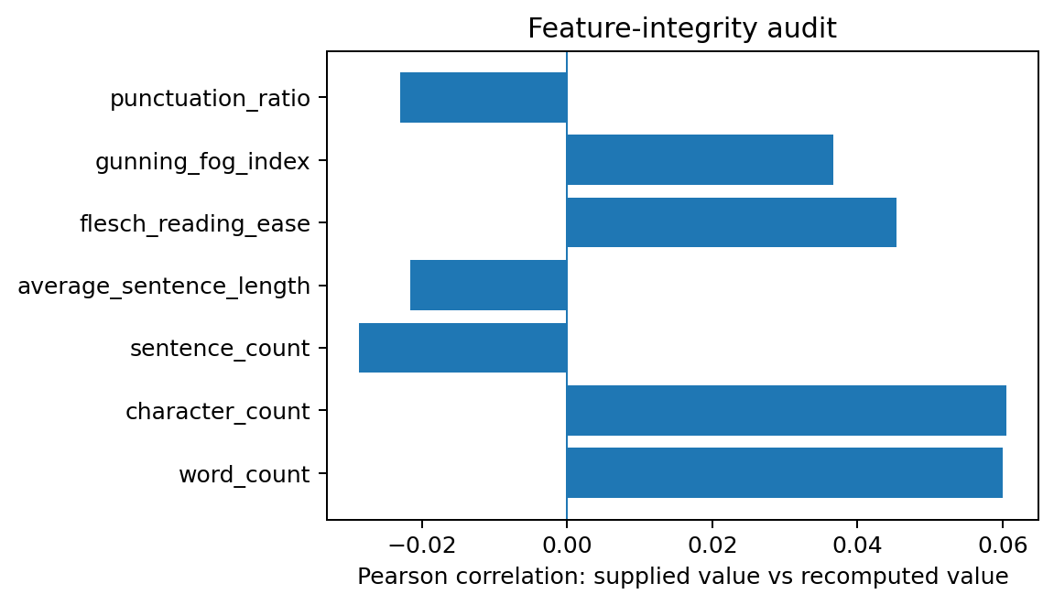
Figure 1. Correlation between supplied feature values and independently recomputed text values.

7.1 Literal-count anomaly
Supplied count field | Rows with non-integer values | Interpretation
word_count | 0 | No non-integer anomaly
character_count | 1,367 | All rows are non-integer despite being labelled as a count
sentence_count | 1,367 | All rows are non-integer despite being labelled as a count

For example, character_count contains values such as 2530.812446. A literal count of characters cannot naturally contain a fractional part. This does not prove malicious leakage, but it is strong evidence that these columns were generated or transformed in a way that is not documented by their names alone.
Decision arising from the audit
The supplied seven-feature baseline is retained only as a diagnostic comparison. The deployable model is built from features recomputed directly from text_content because those are reproducible for future user input.

8. Final Revised Modelling Pipeline
The final revised notebook treats the 100% result as a data-quality and generalization problem rather than a target score to be reduced mechanically.
Final pipeline
Raw text → dataset/duplicate audit → deterministic seven-feature extraction → feature-integrity comparison → stratified 80/20 split → regularized Random Forest → 5-fold StratifiedKFold GridSearchCV → independent test → train/test gap diagnostics → feature importance → model bundle → Gradio dashboard.

8.1 Leakage-oriented guardrails
- Rows with missing text or labels are removed before modelling.
- Exact duplicate text is checked before train/test splitting.
- The held-out 20% test set is not used to select hyperparameters.
- The model reports training and test metrics together so a large generalization gap cannot be hidden behind one accuracy value.
- The saved model bundle includes the exact feature order and target mapping.
- The Gradio prediction function calls the same feature extractor and same trained model as the evaluation pipeline.

8.2 Regularized search space in the final notebook
Hyperparameter | Values
n_estimators | 200, 400
max_depth | 4, 6, 8, 12
min_samples_split | 5, 10, 20
min_samples_leaf | 2, 4, 8
max_features | sqrt, log2, 0.5
class_weight | balanced
CV | 5-fold StratifiedKFold, shuffled, random_state=42
Selection metric | F1 score

9. Performance Results
Three result states are useful for understanding the evolution of the project. The first is the original all-numeric model, the second is a diagnostic seven-supplied-feature baseline, and the third is the reproducible seven-feature model derived from raw text.
Model state | Train Acc. | Test Acc. | Train F1 | Test F1 | Precision / Recall | Interpretation
Original all-numeric model | 100.00% | 100.00% | 100.00% | 100.00% | 100.00% | Perfect held-out separation; treated as leakage/data-artifact red flag
7 supplied CSV features | 84.17% | 73.36% | 85.35% | 76.83% | 67.98% / 88.32% | Moderate test score, but supplied values fail feature-integrity audit
7 recomputed raw-text features | 85.64% | 51.09% | 85.48% | 48.06% | 51.24% / 45.26% | Reproducible from text, but near-chance generalization and a large train-test gap

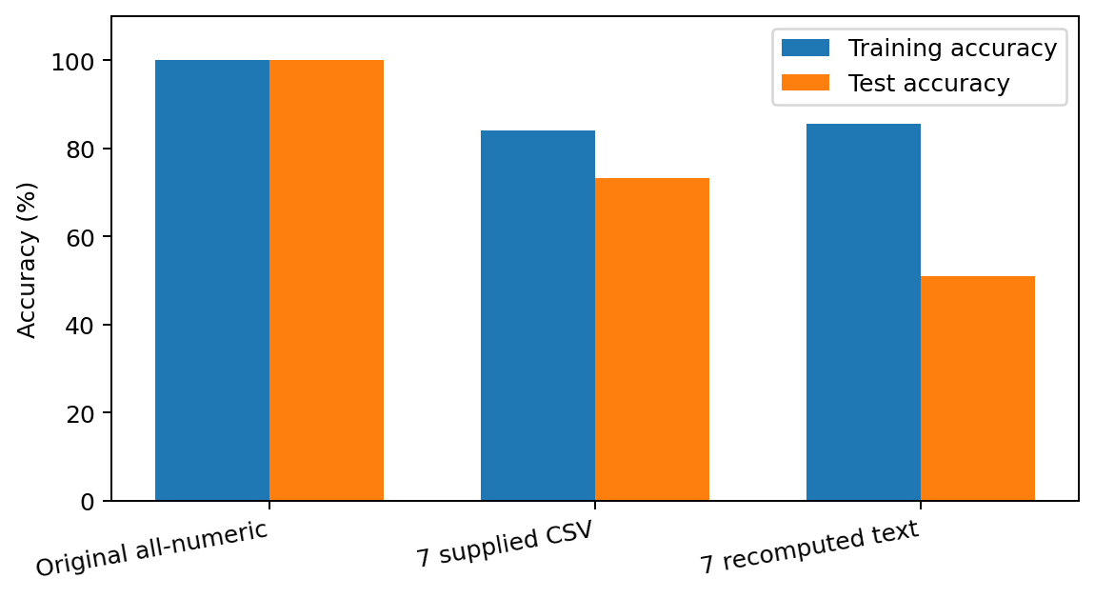
Figure 2. Training and test accuracy across the three project states.

9.1 Recomputed raw-text model confusion matrix
Actual / Predicted | Human | AI
Human | 78 | 59
AI | 75 | 62

The model correctly classified 78 Human texts and 62 AI texts, while misclassifying 59 Human texts as AI and 75 AI texts as Human. Test accuracy was approximately 51.09%, and the test F1 score for the AI class was approximately 48.06%.

9.2 Generalization gap
Training accuracy of approximately 85.64% compared with test accuracy of approximately 51.09% yields a gap of about 34.55 percentage points. Training F1 of approximately 85.48% compared with test F1 of approximately 48.06% yields an F1 gap of about 37.42 percentage points. These are strong overfitting signals.
Performance conclusion
The defensible raw-text pipeline does not currently support a claim of reliable Human-vs-AI detection. The current seven linguistic features are too weak and/or unstable for this dataset. The technically correct response is to improve the data and representation, not to tune until a cosmetically attractive accuracy is obtained.

10. Interpretation of Results

10.1 What the 100% result means now
The perfect original result demonstrates that the supplied numeric feature space contains enough information to separate the labels almost deterministically. It does not demonstrate that a new arbitrary text pasted by a user can be classified perfectly from its observable writing characteristics.

10.2 What the ~73% supplied-seven-feature result means
The selected supplied columns retain substantial predictive signal. However, because those values do not match the same quantities recomputed from the raw text, the model cannot rely on them in a transparent deployment unless their provenance and transformation logic are recovered and verified.

10.3 What the ~51% raw-text result means
The seven basic linguistic summaries do not contain enough stable information to distinguish the classes in this dataset. The high training score shows the forest can still fit interactions in the training set, while the near-chance test score shows those interactions do not generalize.

10.4 What has been ruled out
- Simple class imbalance: the target is almost exactly balanced.
- Exact duplicate-row leakage: zero exact duplicate rows were found.
- Exact duplicate-text leakage: zero exact duplicate text_content values were found.
- A mere lack of Random Forest capacity: the forest fits the training data strongly; generalization, not capacity, is the main issue.

11. Gradio Deployment Architecture
The final revision corrects an important architectural inconsistency from the original notebook. The dashboard no longer trains or calls a separate model with a different feature representation.
Component | Final behavior
Input | User pastes raw text into Gradio
Feature extraction | The same deterministic extract_text_features() function calculates the seven modelling variables
Model | The same tuned Random Forest used in notebook evaluation
Output | Predicted class plus class probabilities
Saved bundle | Model, feature order, target mapping, and feature-definition note

This alignment is essential: an evaluation metric is meaningful for deployment only when the inference path reproduces the training representation exactly.

12. Recommendations to Improve Accuracy
The evaluation indicates that further Random Forest tuning alone is unlikely to solve the central problem. The highest-value improvements are upstream: data provenance, feature quality, and validation design.

1. Rebuild or verify the dataset feature pipeline
Recover the code or method that produced the supplied numerical columns. If character_count, sentence_count, predictability_score, burstiness, grammar_errors, and similar fields were generated synthetically, document the exact transformation and confirm that the same transformation can be applied to unseen raw text without using label/source information.

2. Expand legitimate stylometric features
Keep the seven basic features but add reproducible signals such as lexical diversity, average/variance of word length, sentence-length variance, unique-word ratio, stop-word ratio, uppercase ratio, digit ratio, paragraph count, repeated-word ratio, punctuation-type frequencies, function-word frequencies, transition-word frequency, repetition measures, and burstiness calculated directly from text.

3. Add compact word/character n-gram information
Seven scalar summaries discard most of the text. TF-IDF word and character n-grams can capture phrase fragments, spacing, punctuation, and local style. If Random Forest must remain the only classifier, compress the high-dimensional representation first (for example, truncated dimensionality reduction) and combine it with the stylometric features.

4. Use source-aware validation
If the dataset contains information about author, prompt, AI model, topic, or collection source, ensure related samples are not split randomly across train and test. Test on unseen sources to measure whether the detector learned general AI-writing characteristics rather than source identity.

5. Detect near-duplicates
Exact duplicates were absent, but semantically or lexically near-identical texts can still cross the split. Use cosine similarity, MinHash, or another similarity method to detect and group near-duplicates before splitting.

6. Use repeated stratified cross-validation
Repeat stratified folds across multiple random seeds. Report mean and standard deviation, not one lucky split. A stable 68% is more credible than a single 80% result that collapses under a different seed.

7. Diagnose importance robustly
Keep post-training Random Forest importance but add permutation importance. If one variable dominates and its provenance is unclear, treat that as a data-quality investigation trigger.

8. Increase diversity, not merely volume
Add Human text from multiple authors/topics and AI text from multiple models, prompts, temperatures, lengths, and editing conditions. More rows generated from the same source process may reinforce artefacts rather than improve generalization.

9. Separate detector development from score chasing
Do not define success as reaching a particular accuracy band. Define success as reproducible features, stable cross-validation, small train-test gaps, and performance on genuinely unseen sources.

13. Recommended Experiment Roadmap
The next phase should be run as a sequence of controlled experiments so every accuracy improvement has an interpretable cause.
Experiment | Input representation | Validation | Decision criterion
A — Reference baseline | Current 7 recomputed features | Repeated stratified CV + held-out test | Establish stable baseline and variance
B — Expanded stylometry | 20–40 raw-text-derived features | Same splits as A | Keep only if mean CV/test performance improves without a larger gap
C — Stylometry + compact n-grams | Expanded features + reduced TF-IDF representation | Same splits; then source-aware test | Measure added signal from local text patterns
D — Provenance stress test | Best representation | Hold out author/model/topic/source groups | Assess real generalization
E — External validation | Frozen best pipeline | Independent dataset | Estimate transfer beyond the development CSV

13.1 Suggested model acceptance criteria
- Every feature can be reproduced from new raw text with documented code.
- No label/source-derived field is used as an input.
- Cross-validation and held-out test results are reasonably close.
- Performance is stable across repeated splits/seeds.
- Source-aware or external validation remains meaningfully above chance.
- The exact training feature pipeline is reused in the Gradio application.

14. Limitations and Risks
Limitation / risk | Impact
Unknown provenance of supplied feature columns | Prevents a strong claim that the 73% or 100% results reflect genuine text detection rather than dataset-generation signals.
Only 1,367 samples | Limits the diversity that can be represented and increases sensitivity to split composition.
Source diversity not documented in supplied artifacts | Cannot yet establish whether Human authors and AI generators are independently diverse.
Seven-feature raw-text baseline is coarse | Length/readability summaries omit most lexical and local stylistic information.
Approximate syllable estimator | Flesch and Gunning Fog values are internally consistent but may differ from specialist readability libraries.
Binary label only | Does not distinguish AI model families, edited AI text, mixed authorship, or human-assisted AI writing.
No external benchmark supplied | Generalization outside this dataset has not yet been established.

15. Reporting Guidance
For academic or project reporting, the strongest narrative is not “the model was reduced from 100% to 51%.” The defensible narrative is that the project discovered a feature-provenance problem and revised the experimental design to separate dataset artefacts from reproducible raw-text signals.
Recommended wording
“The initial Random Forest achieved 100% held-out accuracy when trained on all supplied numerical variables. Because perfect separation raised concerns about leakage and dataset artefacts, the feature pipeline was audited. Seven linguistic features were independently recomputed from raw text, revealing very weak agreement with the corresponding supplied CSV values. A revised leakage-resistant pipeline using only reproducible raw-text-derived features achieved approximately 51% test accuracy while retaining a substantial training-test gap. The result indicates that the original perfect performance was not a reliable estimate of deployable text-detection performance and that further work should focus on dataset provenance, richer legitimate text features, and source-aware validation.”

15.1 Metrics that should be reported together
- Training accuracy and F1
- Cross-validation F1 (mean and, preferably, standard deviation)
- Held-out test accuracy
- Precision and recall for the AI class
- Test F1 / macro F1
- Confusion matrix
- Train-vs-test or train-vs-CV generalization gap
- Validation design and random seed
- Exact feature definitions and provenance

16. Conclusion
The Human vs Machine project progressed from an apparently perfect classifier to a more rigorous examination of what the model was actually learning. The original all-numeric Random Forest was reproducibly perfect on the development split, but the dataset audit showed that the strongest predictive space included supplied features whose relationship to the raw text is not sufficiently documented. The feature-integrity audit then demonstrated that even basic supplied linguistic columns do not agree with independently recomputed values.
The final revised notebook therefore prioritizes reproducibility over headline accuracy. It derives seven features from raw text, uses stronger Random Forest regularization and cross-validation, exposes generalization gaps, saves a consistent model bundle, and deploys the same pipeline through Gradio. Its approximately 51% held-out accuracy is not a successful detector, but it is an honest baseline that identifies the real next research problem: constructing a richer, better-provenanced, source-diverse representation of Human and AI writing.
Bottom line
The project should move forward by improving the dataset and raw-text feature representation—not by attempting to recover a predetermined accuracy target from questionable supplied columns.

Appendix A. Feature Definitions
Feature | Operational definition
Word Count | Number of word-like tokens matched in the raw text.
Character Count | Length of the raw text string in characters.
Sentence Count | Number of non-empty segments separated by terminal punctuation (. ! ?).
Average Sentence Length | word_count ÷ max(sentence_count, 1).
Flesch Reading Ease | 206.835 − 1.015(words/sentences) − 84.6(syllables/words), using the notebook’s deterministic syllable estimator.
Gunning Fog Index | 0.4 × [(words/sentences) + 100(complex_words/words)], with complex word approximated as ≥3 syllables.
Punctuation Ratio | Number of punctuation characters ÷ total character count.

Appendix B. Key Hyperparameters and Validation Logic
Element | Final notebook choice
Classifier | RandomForestClassifier
Class weighting | balanced
Bootstrap | True
Random seed | 42
Train/test split | 80/20, stratified
Cross-validation | 5-fold StratifiedKFold, shuffled
Scoring metric | F1
Grid — estimators | 200, 400
Grid — max depth | 4, 6, 8, 12
Grid — min samples split | 5, 10, 20
Grid — min samples leaf | 2, 4, 8
Grid — max features | sqrt, log2, 0.5

Appendix C. Reproducibility Checklist
- Keep ai_detection_dataset.csv with the notebook or update the configured path.
- Run the dataset audit before modelling.
- Do not replace the raw-text feature extractor with supplied CSV values unless provenance has been verified.
- Record package versions and random seed for formal submission.
- Run all notebook cells from top to bottom in a clean runtime.
- Save the fitted model bundle only after the final evaluation is complete.
- Confirm the Gradio function calls the same feature extractor and trained model.
- For the next version, add repeated CV and near-duplicate/source-aware validation.
End of report.

